APP SERVERS & WEB SERVERS

1. Install nginx and run nginx on port number 81.

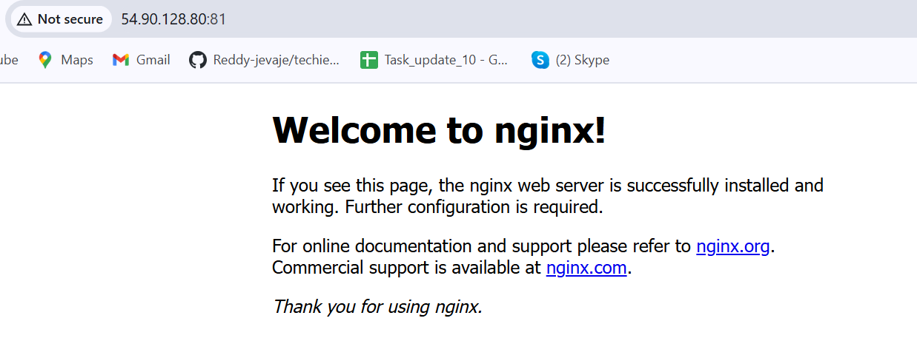

1. Deploy a sample index.html file on nginx.

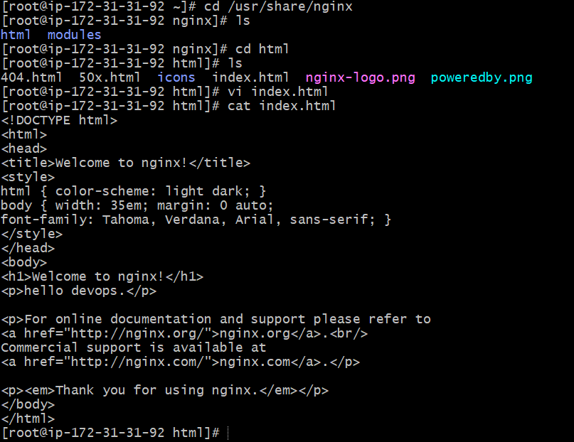

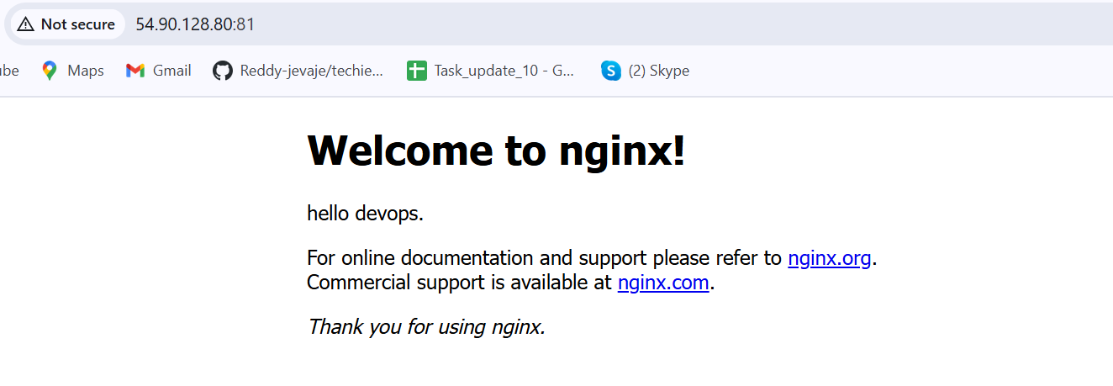

1. Install Apache and run Apache on port number 82

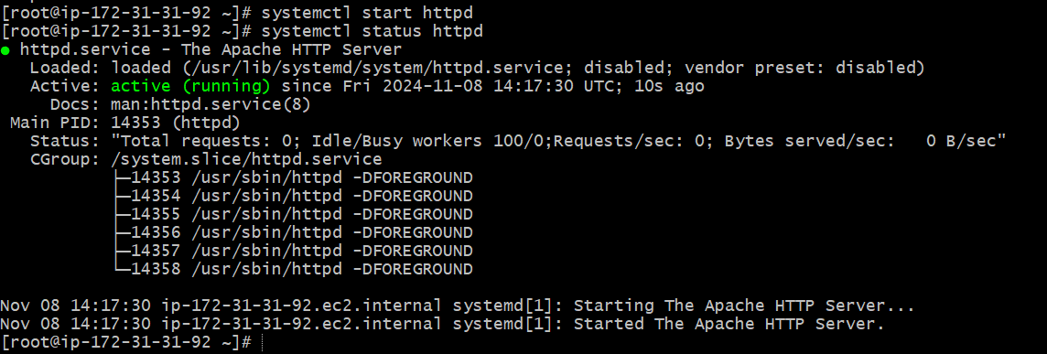

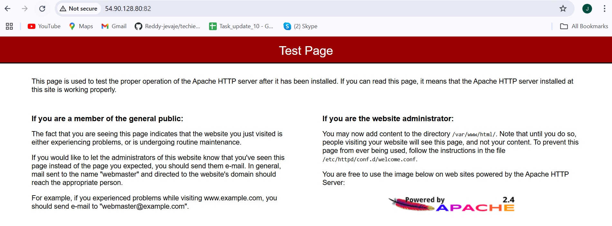

1. Deploy a sample index.html file on Apache.

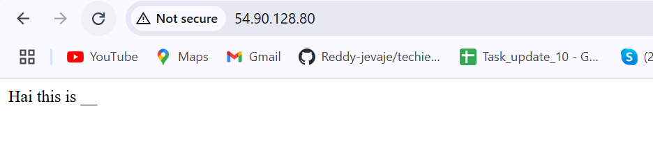

1. Install Apache tomcat on port number 8082

https://dlcdn.apache.org/tomcat/tomcat-9/v9.0.96/bin/apache-tomcat-9.0.96.tar.gz